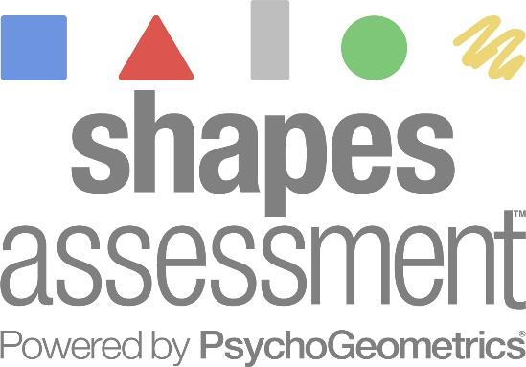
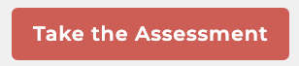

- Click the Red Button above, Take the Assessment,
or go to www.psychogeometrics.com and click on Shapes Assessment on top menu bar.

- Enter your access code: ______________

Please only take the Shapes Assessment once and do not share this access code. We want to be able to compile a group report, and it’s important that you are only counted once. If you experience any technical issues and need to retake the Shapes Assessment, please contact infopgeo@psychogeometrics.com.

- Create your account and choose your own password. Be sure to remember the email you use and your password. This is especially important because after you take the Shapes Assessment, your login information will allow access to your personal account and dashboard, where your Shapes Assessment Results will be accessible and downloadable anytime, along with the Shapes Guide.

- It takes 15 minutes or less to take the Shapes Assessment. There are three sections. Be sure to choose your responses based on how you are “naturally.” The Shapes Assessment is designed to capture your natural strengths.

- Review your personal Shapes Profile Report and the downloadable Shapes Guide. Doing these two things will enhance your learning experience.

